**MINOR PROJECT REPORT**

**REAL-TIME ATTENDANCE AND ENGAGEMENT DETECTION IN CLASSROOMS USING DEEP LEARNING AND COMPUTER VISION**

Submitted in partial fulfilment of the requirements for the award of the degree of

**B. TECH IN COMPUTER SCIENCE AND ENGINEERING**

**Submitted by:**

**Karan Malik**

**02216403218**

**B.Tech CSE 2018-22**

**Rigved Alankar**

**40116403218**

**B.Tech CSE 2018-22**

**Submitted to:**

**Dr. Ruchi Sehrawat**

**Assistant Professor**

**USICT, New Delhi**



**UNIVERSITY SCHOOL OF INFORMATION, COMMUNICATION AND TECHNOLOGY**

## GURU GOBIND SINGH INDRAPRASTHA UNIVERSITY

## NEW DELHI, 110078

**Index**

|  |  |  |
| --- | --- | --- |
| S No. | Section | Page Number |
| 1 | Mentor Approval | 3 |
| 2 | Abstract | 4 |
| 3 | Introduction | 4 |
| 4 | Problem Statement | 4 |
| 5 | Methodology and Algorithms  Formulated | 5 |
| 6 | Project Workflow | 9 |
| 7 | Dataflow Diagrams | 9 |
| 8 | Hardware and Software Requirements | 10 |
| 9 | Working and Code | 10 |
| 10 | References | 20 |

**Mentor Approval**



Dr. Ruchi Sehrawat

Assistant Professor, USICT, New Delhi

**Abstract**

For an effective classroom environment, it becomes important to track the activities and the state of the students taking the lecture. This becomes increasingly important owing to the difficulties faced by students and teachers in the transition from offline to online teaching due to the pandemic, followed by the gradual reinstating of offline teaching. This project entails the usage of deep learning algorithms and computer vision techniques including facial detection and recognition for real-time attendance of the students in both offline and online settings. Moreover, engagement detection practices, such as drowsiness detection and gaze detection to maintain the sanctity of a classroom have also been proposed.

**Introduction**

Studies show that student’s attendance has a strong positive correlation with their performance in classrooms [1], however, mid-class attendance along with factors such as inattentiveness of students often disturb a classroom. A considerable part of each lecture is spent recording students’ attendance and our proposed system circumvents this limitation and allows for a more productive learning environment.

We plan to create an Artificial Intelligence based system that uses the face recognition algorithm *Local Binary Patterns Histogram* [2]*,* to detect faces in a classroom setting – both offline and virtually. The student’s presence/absence will then be updated in this database depending on it

Apart from real-time attendance, we also plan to incorporate student engagement detection in the classroom – using drowsiness detection, gaze detection and mobile-phone detection. For drowsiness detection, we aim to use facial landmark detection to detect eyes' coordinates, which can be used to compute the metric – Eye Aspect Ratio to tell us whether the eye is open or closed.

Testing of the system has been done on both, freely available datasets [3] as well as real-world data which we our system collects using webcam live streams.

As for the project timeline, we plan to incorporate real-time attendance and drowsiness detection in this semester as a part of the minor project and then extend the project by adding gaze and mobile phone detection, along with creation of a web interface for our major project in the next semester.

**Problem Statement**

Real-time Attendance and Engagement Detection in Classrooms using Deep Learning and Computer Vision

**Methodology and Algorithms Formulated**

**Smart Attendance System**

The architecture of the Smart Attendance System is as follows:

1. A camera – webcam or CCTV should be installed in front of the students so that it can capture the face of the student.
2. After the image has been captured; the captured image is transferred into the system as an input.
3. To circumvent the variability in the brightness of the images received, the images are converted to grayscale.
4. Futher, OpenCV’s haarcascade 68-points shape predictor is used to detect faces and then extracting these facial images for the face recognition systems.
5. If the user is not already registered, they can at this point use the system to capture images to be used for recognition and register themselves with our system.
6. In the next step, the LBPH algorithm has been used to recognise faces of the registered users.
7. Finally, the attendance of the users detected i.e., their name, ID and the current date and time are exported and saved as a CSV file.

**Local Binary Patterns Histogram (LBPH) Algorithm**

Local Binary Pattern(LBP) is a simple yet very efficient texture operator which labels the pixels of an image by thresholding the neighbourhood of each pixel and considers the result as a binary number. When LBP is joined with histograms of oriented gradients (HOG) descriptor, it improves the efficiency and accuracy considerably for some datasets. Moreover, utilizing LBP joined with histograms allows us to represent facial images using simple data vectors, thus making it more suitable for face detection tasks.

The LBPH algorithm works in 5 steps as given below:

**a) Parameters: LBPH uses 4 parameters:**

● Radius: the radius is used to create a local binary pattern and represents the radius around the centre pixel. The frequency is set to 1.

● Neighbours: the number of sample points to form the circular binary pattern. Higher the number of neighbours, the higher the computational cost. The frequency has been set to 8.

● Grid X: the number of cells in the horizontal direction. Using larger values for Grid X i.e., a more precise and finer grid allows higher dimensionality for the resulting vector. The frequency is set to 8.

● Grid Y - the number of cells in the vertical direction. Using larger values for Grid Y i.e., a more precise and finer grid allows higher dimensionality for the resulting vector. The frequency is set to 8.

**b) Creating the dataset**

The first step is to train the model. To do so, we use a database that contains images of people who are to be recognized i.e., our training data. Next, an identifier, such as a name or an identification number, is added to all the images to allow the algorithm to identify the input image. Multiple photos of the same person must have the same ID.

**c) Applying the LBP operation**

Next thing is to create an intermediate image that highlights the facial features of the original image. To do so, the algorithm law uses a sliding window which varies with change in the the parameters – radius and neighbours.

● We have a grayscale face image [5].

● Get a 3x3 pixel window from the image, with each number in the matrix showing the intensity of the corresponding pixel from 0-255.

● Find the central value of the matrix and use it as a threshold.

● Reassign the values of the remaining 8 neighbours – value=1 for pixels with equal or higher intensity than the threshold and value=0 for the others.

● Now, the matrix will contain only binary values. Concatenate the 8 binary values together to form a new 8-bit binary value. (e.g. 10001101).

● After that, we convert this binary number to a decimal value and set it to the center value of the matrix, which is a pixel from the first image.

● At the end of this process (LBP process), we have a new image that better represents the features of the original image.

**d) Recording Histograms:**

Now, using the image created in the last step, we can use the Grid X and Grid Y parameters to split the image into multiple grids, as can be seen in the following image [5]:

- Since we have a grayscale image, each histogram (from each grid) will only contain 256 (0 ~ 255) positions representing each pixel intensity.

- Further, a larger histogram is created by concatenating each histogram. If we assume we have 8x8 grids, we will have 8x8x256 = 16.384 positions in the final histogram. The final histogram represents the features of the first image.

**e) Performing face recognition:**

At this point, the algorithm is already trained. Each created histogram is used to represent each image from the training database. Whenever an image is input to the system, the following steps are retraced and a histogram is created for the given image.

To find the most similar image from the database to the input image, we just need to compare the two histograms and return the image with the nearest histogram.

We can use various methods to compare histograms (calculating the distance between two histograms), for example, Euclidean distance, square-chi, total value, etc. In our implementation, we use the Euclidean distance based on the following formula:

**Distance Between two histograms**

So, the calculation output is an ID from a picture with a close-by histogram. The calculated distance can be utilized as a measure of 'confidence'.

**Detecting drowsiness**

Using facial landmark detection to localize important regions of the face, including eyes, eyebrows, nose, ears, and mouth allows us the leverage to extract [*specific facial structures*](https://pyimagesearch.com/2017/04/10/detect-eyes-nose-lips-jaw-dlib-opencv-python/) by knowing the indexes of the particular face parts: In terms of drowsiness detection, we are only interested in two sets of facial structures — *the eyes.*

Each eye is represented by 6 *(x, y)*-coordinates, starting at the left-corner of the eye and then working clockwise around the remainder of the region:

***The 6 facial landmarks associated with the eye.***

Based on the work by Soukupová and Čech in their 2016 paper, [*Real-Time Eye Blink Detection using Facial Landmarks*](http://vision.fe.uni-lj.si/cvww2016/proceedings/papers/05.pdf),[4] we can then derive an equation that reflects the relation between the width and height of the eye, called the*eye aspect ratio* (EAR):

***The eye aspect ratio equation.***

Where *p1, …, p6* are 2D facial landmark locations.

The numerator of this equation computes the distance between the vertical eye landmarks while the denominator computes the distance between horizontal eye landmarks, weighing the denominator appropriately since there is only *one* set of horizontal points but *two* sets of vertical points.

The eye aspect ratio is approximately constant while the eye is open but will rapidly fall to zero when a blink is taking place.

Using this simple equation, we can *avoid image processing techniques* and simply rely on the *ratio of eye landmark distances* to determine if a person is blinking.

***Top-left: A visualization of eye landmarks when then the eye is open. Top-right: Eye landmarks when the eye is closed. Bottom: Plotting the eye aspect ratio over time. The dip in the eye aspect ratio indicates a blink (Figure 1 of Soukupová and Čech).***

On the *top-left* we have an eye that is fully open — the eye aspect ratio here would be large(r) and relatively constant over time.

However, once the person blinks (*top-right*) the eye aspect ratio decreases dramatically, approaching zero.

The *bottom* figure plots a graph of the eye aspect ratio over time for a video clip. As we can see, the eye aspect ratio is constant, then rapidly drops close to zero, then increases again, indicating a single blink has taken place.

**Project Workflow**

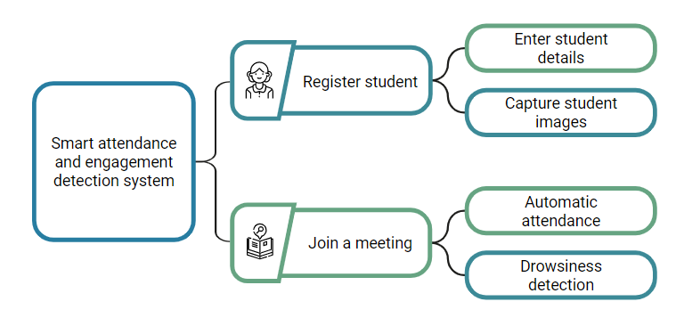

**Dataflow Diagrams**

**Registering a student**

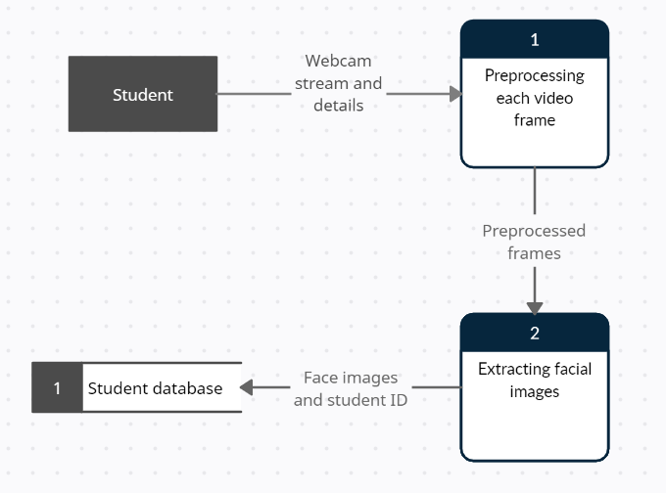

**Automatic attendance and drowsiness detection**

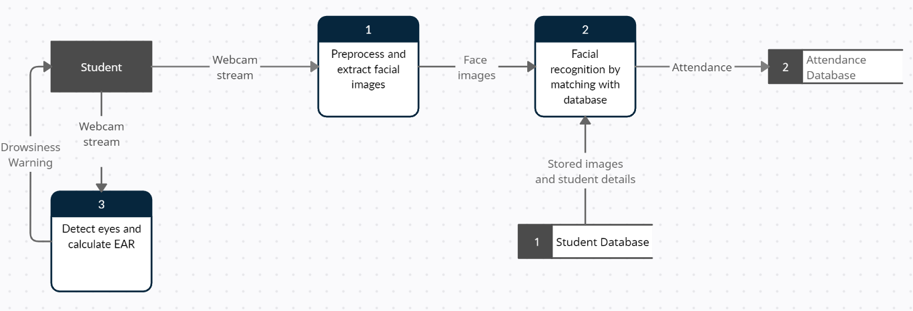

**Hardware and Software Requirements**

Hardware Requirements:

1. CCTV cameras - for capturing students’ images to be used for attendance and engagement detection
2. Webcam – to accomplish the same tasks in an online setting.

Software Requirements:

1. Programming language to be used: Python (for developing the system) and HTML/CSS (for developing the web interface)
2. Frameworks: Scikit-Learn, Tensorflow, Keras, OpenCV, NumPy etc.
3. Hosting the system on local host: Flask Web Development

**Working and Code**

In our model, we will be providing the users with the options to choose a given function from the above possible functions, the pseudocode for the same is given below:

1. Register

2. Join a Class

3. Train Images

4. Recognize & Attendance

5. Drowsiness Detection

6. Quit

***The main menu of the working model***

Pseudocode:

Begin

● if choice = 1

call the function to register a new student and retrain the LBPH model

● elif choice = 2

call the function which uses face recognition to identify the person and then mark attendance in a CSV file while also detecting for signs of drowsiness and warning the student if required

● elif choice = 3

call the function which manually retrains images

● elif choice = 4

call the function which uses face recognition to identify the person and then mark attendance in a CSV file

● elif choice = 5

call the function that detects drowsiness

● else exit

End

**Face recognition steps and working:**

*Step - 1: Finding all the Faces*

We start by looking out for faces in an image. Initially the image is converted to grayscale as colour data isn't required to identify or recognize faces and this allows our model to reduce its computational requirements. Then the pretrained model, haarcascade, provided by OpenCV has been used to detect all the faces in the input image.

***Face getting detected by the model***

*Step 2: Training the model*

In this step, the face image is encoded and the LBPH model trainer is used and the model is trained using the images in the dataset.

***Snapshots captured while training the faces***

From the figure above, it can be noticed that ~30-40 images get captured and stored in the database/ local storage. These images are then used to detect and recognize the person to mark the attendance.

***Function to train images in Python***

*Step 3: Compare against known faces*

In this step, the model trained and stored in the previous step is used. An image which is input to the model is preprocessed and face images are extracted. Then the LBPH predict function is used to identify the facial image from the dataset closest to the image which is received.

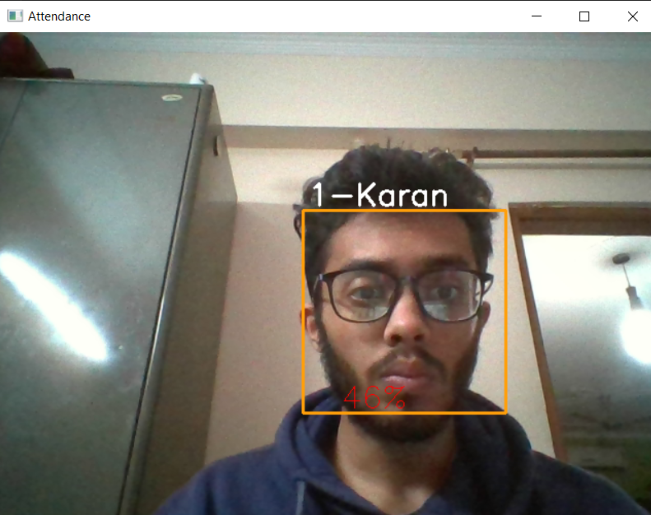

***Predicting face using LBPH model***

*Step 4: Marking attendance*

The face is recognized, and the attendance is marked for the recognized person, along with a timestamp. This attendance is then stored in a CSV file

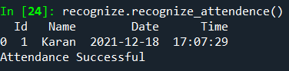

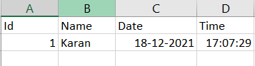

***Fig. Marked attendance and CSV file***

**Drowsiness detection steps and working:**

*Step - 1: Finding facial landmarks*

For this, we use OpenCV’s face landmark estimation. The library allows us to return sixty-eight specific points (landmarks) including the upper part of the chin, the skin fringe of every eye, the inner fringe of the eyebrow, etc.

***Front and side poses***

This allows us to locate the eyes.

*Step - 2: Calculating the eye aspect ratio*

The above detected landmarks are then used to calculate the eye aspect ratio.

***Calculating EAR***

*Step - 3: Detecting drowsiness*

If the calculated EAR is below a given threshold, a warning is displayed on the screen.

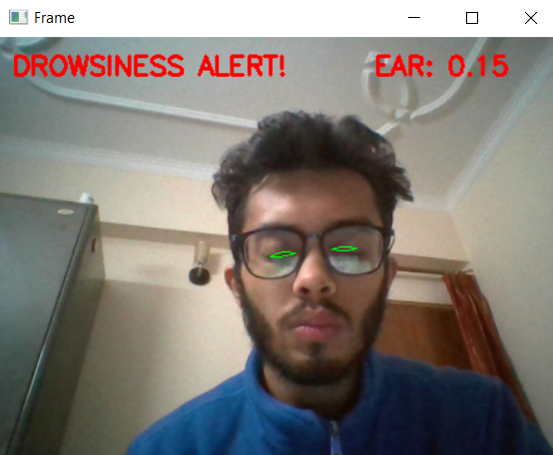

***Detecting drowsiness***

**Tasks Completed**

We have created the models for real-time attendance and for detecting drowsiness from the captured images.

All our code is written in Python. Below are the important python codes which are the core of our implementation of this software engineering project.

1. Dataset: Where all the face images are saved.

2. main.py: Main program file to run the program.

3. train_image.py: Train the captured images and work on datasets.

4. recognize.py: To recognize and mark attendance

5. detect_drowsiness.py: To detect drowsiness in the captured images

**a) main.py**

This is the main python code for our project that includes functions from other files and has all the options which are allowed in the user interface. Once this file is run, the user gets to choose whatever action has to be taken place, say whether it is to capture an image or to train an image, etc. The main function calls the other functions and specifies options to the user.

**b) train_image.py**

In this step, the image gets trained with database images and machine learning techniques. This is done by making use of a haarcascade classifier. Once the images are trained and the model is ready for the next step, the “image trained“ message appears on the screen.

**c) recognize.py**

In this step, the faces are recognized with the help of the LBPH Face recognizer function. Along with this, the time and date also get recorded. If the function works successfully then the attendance is marked for the recognized face.

**d) detect_drowsiness.py**

**References**

1. T. Godson ‘*Effects of Classroom Attendance and Learning Strategies on the Learning Outcome’* Journal of International Education in Business (2018).
2. Ahonen, Timo, Abdenour Hadid, and Matti Pietikainen. “**Face description with local binary patterns: Application to face recognition**.” IEEE transactions on pattern analysis and machine intelligence 28.12 (2006): 2037–2041.
3. P.E. Kekong, I.A. Ajah & U. Chidiebere, ‘Real Time Drowsy Driver Monitoring and Detection System Using Deep Learning Based Behavioural Approach’ International Journal of Computer Sciences and Engineering (2021).
4. Soukupová, Tereza and Jan Cech. “*Real-Time Eye Blink Detection using Facial Landmarks*.” (2016).
5. https://towardsdatascience.com/face-recognition-how-lbph-works-90ec258c3d6b